Eating well with COVID-19
Important points to remember
- Eating and drinking can be difficult when you have COVID-19, but good nutrition will help you to get better
- Eating small meals more often that are high in energy and protein can help you to meet your nutrition needs and keep up your strength while you are getting better

This document should not replace the advice of your relevant health care professional.

Why is it important?
It can be difficult to eat and drink well when you are unwell, but good nutrition is important to help you get better.
Eating well is important to:
- Give your body energy to fight the infection
- Stop unplanned weight loss
- Give you the strength and energy to do everyday activities
- Get you back to feeling more like yourself again

COVID-19 side effects
It is very common for people with COVID-19 to have symptoms that can make it difficult to eat well. These include:
- Loss of appetite
- Nausea and vomiting
- Diarrhoea
- Loss or changes to taste and smell
- Shortness of breath, especially while you are eating
- Fatigue and difficulties with making food

A COVID-19 infection also increases the amount of energy (kilojoules) and protein your body needs. This means you may lose weight and strength while you are sick.

Losing weight when you are unwell is not recommended as it may take you longer to get better.
Some people with COVID-19 do not have any symptoms affecting their eating and are able to maintain good nutrition throughout their illness. For these people, a healthy and balanced diet is recommended as well as regularly checking your weight.

High energy, high protein foods
If you are eating less than usual, it is important to eat foods that are high in energy and protein so you do not miss out on the important nutrition your body needs to get better.

High energy foods:
- Full fat dairy foods – including milk, cheese and cream
- Fats, oils and spreads – butter, oils, avocado, tahini, peanut butter
- Desserts – custard, ice cream, cakes, chocolate, rice pudding

High protein foods:
- Dairy foods – milk, cheese and yoghurt
- Soy products – tofu, soy milk, tempeh
- Legumes and lentils – baked beans, chickpea foods such as hummus or falafel
- Meats, fish and seafood, and eggs

Recommendations
- Make every mouthful count by having more high energy and high protein foods in your meals and snacks
- If large meals are too much, try having six small and regular meals across the day
- Find the foods you find easiest to eat with your symptoms and try to focus on eating those foods
- Weigh yourself once a week and keep a record. Let your doctor know if you are losing weight

Need more help?
- Let your doctor know if you are struggling with eating and drinking or you are losing weight.
- If you need more help with your eating talk to your doctor about seeing a dietitian.
- To find a dietitian near you, visit Dietitians Australia at dietitiansaustralia.org.au/find-an-apd

High energy foods
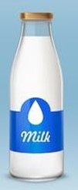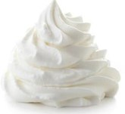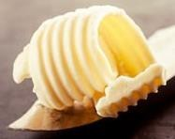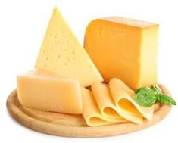
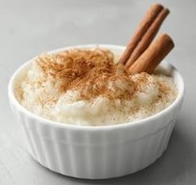
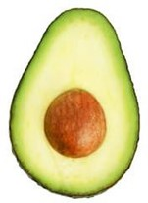
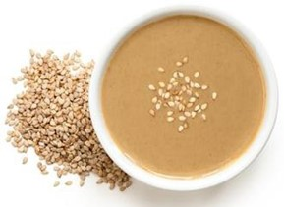

High protein foods
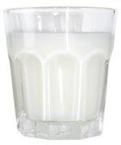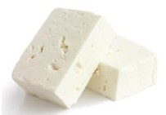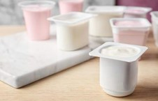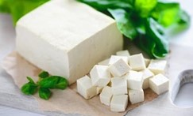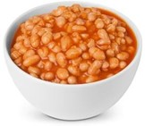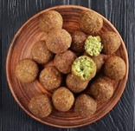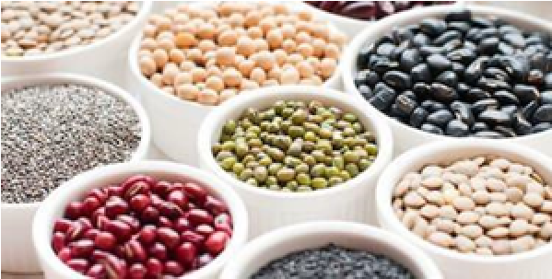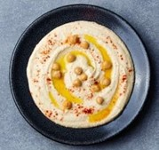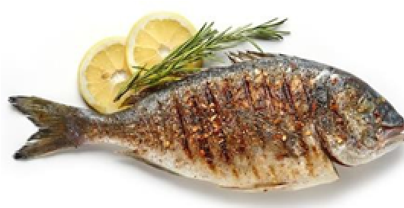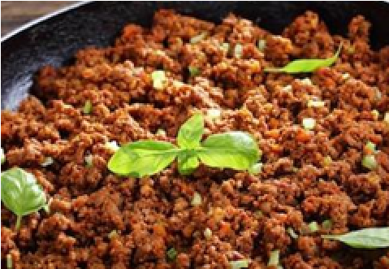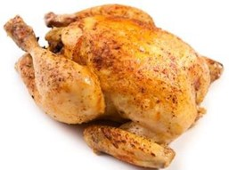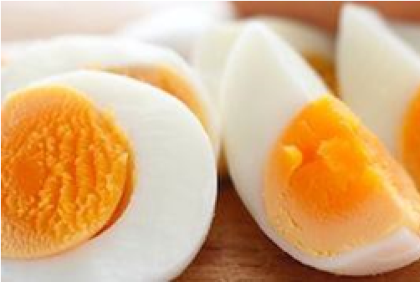

For further information
Department: Nutrition Department
Phone: 9496 5011
Date produced: October 2021
Date for review: October 2024

This document was reproduced with permission of Royal Melbourne Hospital, Nutrition and Dietetic Department.

